Unit VI (Ch. 19-21) Test Review

Terms
ability-to-pay principle
artificially scarce good
benefits principle
Coase Theorem
deadweight loss
efficiency v. inefficiency
environmental standards
external cost
externalities (negative and positive)
free rider problem
marginal social benefit (MSB)
marginal social cost (MSC)
marketable permits
Pigouvian taxes and subsidies
pollution
poverty line
poverty rate
private v/ public goods
socially optimal price and output
tax incidence (burden of a tax)
taxes (payroll, proportional/flat, progressive, sales, excise, property, income, and regressive)
tradeable emissions permit

Types of Goods Matrix

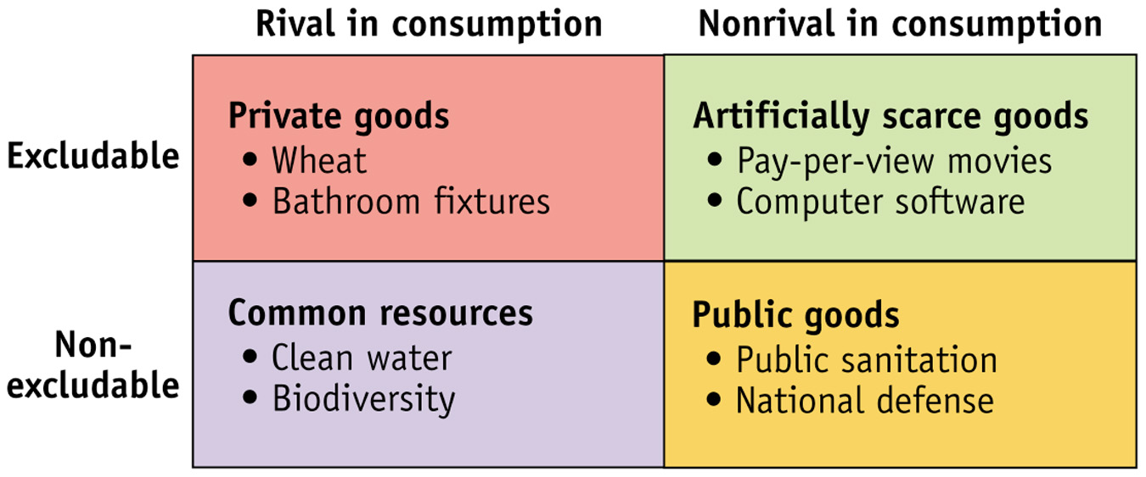
Models to Know
